The Era of Moses' Law lasted one thousand five hundred and twenty years and Biblically spans from Exodus to the fourth Gospel, the Book of John. The books of Matthew, Mark, Luke, and John are known as the Gospels and tell the story of the coming of the Messiah, Jesus Christ, and the events that ushered in a new Era of Grace. To better understand the events of the time of Christ and the New Testament, it is needful to present a short synopsis of the history of the Israeli people through the Era of Law. By placing the important events in chronological order, this study will enable you to be able to read anywhere in the Old Testament and understand the setting and time of which you read.

We have already studied the eras of Innocence, Conscience, Human Government, and Promise in great detail. These first steps of God's progressive plan are all recorded in the first book of the Bible, the book of Genesis. Appropriately, "genesis" means "beginnings."

We have also already detailed how that God sent Moses to lead the nation of Israel out of the Egypt. Also appropriately named, the book of Exodus details this mass exodus of the Israeli nation from the slavery of Egyptian rule. It also tells the story of Moses' receiving of the six hundred and thirteen laws from God, the blueprints and building of the Tabernacle, and how God miraculously fed and kept the nation in the wilderness.

"Leviticus" means "pertaining to the Levites" and as the Levites were the priests of the Era of Law, the book of Leviticus details the ceremonial law and duties of the Mosaic priesthood.

Ex 3:8 "So I have come down to deliver them from the power of the Egyptians, and to bring them up from that land to a good and spacious land, to a land flowing with milk and honey, to the place of the Canaanite and the Hittite and the Amorite and the Perizzite and the Hivite and the Jebusite.

It was God's intention to deliver Israel from Egypt, give them His law and commandments, and then lead them directly to the Promised Land, that He had first shown Abraham. When the children of Israel arrived on the border of the land of Canaan and twelve spies came back with a report of how big the inhabitants of the land were and how greatly fortified the cities were, most of the people began to fear and doubt God's ability to help them fight and win the land that He had promised. Two of the spies, Joshua and Caleb, tried to rally the people to faith by declaring that God would help them conquer the giants in the land, but their efforts failed and an entire generation refused to believe that the God that had delivered them from Egypt could deliver the Promised Land into their hands! In response to their doubt, God spoke:

Num 14:29-31 your corpses will fall in this wilderness, even all your numbered men, according to your complete number from twenty years old and upward, who have grumbled against Me. 30 'Surely you shall not come into the land in which I swore to settle you, except Caleb the son of Jephunneh and Joshua the son of Nun. 31' Your children, however, whom you said would become a prey — I will bring them in, and they will know the land which you have rejected.

God refused to let the generation of doubt into the Promised Land and caused them to wander in circles for forty years until every person who had been over the age of twenty at the time of disbelief was dead. Of that first generation, only Joshua and Caleb would enter into the Land of Canaan and inherit the promises of God. The sad story of Israel wandering about in the wilderness awaiting the deaths of the doubters is recorded in the book of Numbers. It is named after the many censuses and "numberings" that are a frequent occurrence in the book.

Because of his disobedience to a specific command, God would not allow Moses to enter into the Promised Land either. At the end of the wilderness years, Moses led the people to the edge of the Land of Canaan, and prepared to die by addressing the nation in a series of farewell speeches. These speeches are recorded in the book of Deuteronomy. "Deuteronomy" means "the law a second time" and the book is largely a recap and retelling of the laws and ceremonies found in the books of Exodus and Leviticus.

Deut 34:9 Now Joshua the son of Nun was filled with the spirit of wisdom, for Moses had laid his hands on him; and the sons of Israel listened to him and did as the LORD had commanded Moses.

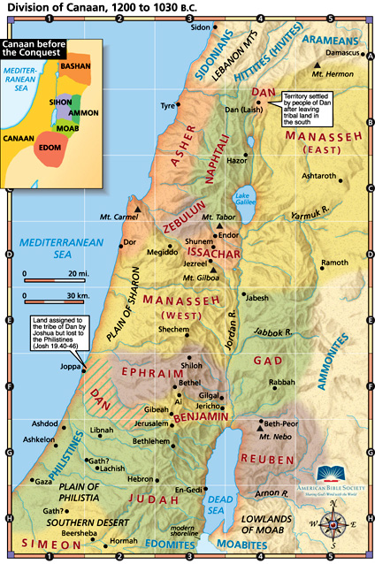
Before he died, Moses passed the mantle of leadership on to the faithful Joshua. Joshua then led the next generation of Israelites into the Promised Land and into the fight for their inheritance following God's guidance. Perhaps the most famous battle of this campaign is recorded in the 6th chapter of Joshua where in the conquest of the city of Jericho, the children of Israel obediently marched around the city for seven days and upon the seventh day, after the seventh time around the city, they began to shout and praise God and the great walls of the city fell flat before them! After conquering Canaan, Joshua divided the land among the tribes and Israel renewed their covenant with God before going to their new homes. The book of Joshua is the written record of all these events. Joshua ended the final meeting with the nation with these famous words:

Josh 24:15-16 "If it is disagreeable in your sight to serve the LORD, choose for yourselves today whom you will serve: whether the gods which your fathers served which were beyond the River, or the gods of the Amorites in whose land you are living; but as for me and my house, we will serve the LORD." 16 The people answered and said, "Far be it from us that we should forsake the LORD to serve other gods;

Once the children of Israel were divided into tribes by territory there was no official national leader, and God intended for His law and priests to govern the people. Unfortunately, without a physical leader, the people often gave into the influence of the idolatrous people around them and worshiped other gods. There were certain men – and a woman – who arose throughout these years as judges, and this period of Israel became known as "the time of Judges" and is recorded in the book of Judges. Some of these judges served the Lord; some did not. Some were prophets; some were not. They mainly served as military leaders and usually arose because of some crisis that resulted as judgment from Israel's sin. Typically, Israel would fall into idolatry and God would send another nation to oppress them. A judge would rise up and try to deliver Israel. The following is a list of all the judges mentioned in scripture along with the crisis that they faced and the verses in the book of Judges that record their story.

Othniel of Judah – delivered Israel from the King of Mesopotamia after eight years of servitude (Judges 3:5-9). Othniel was the nephew of Caleb, the other spy who refused with Joshua to doubt the promises of God.

Ehud a Benjamite and Shamgar – delivered Israel from Moab by personally killing their king, Eglon, in his own palace and then slaying 10,000 of the Moabite army (Judges 3:12-31). Ehud was left-handed and when he stabbed the fat Eglon, the knife was engulfed by the flesh and was left behind!

Deborah and Barak – defeated the Canaanite army of 900 chariots and 10,000 men. During the battle, a furious storm broke out causing the famous archers of the Canaanite army defenseless. Floodwaters then caused the chariots to bog down in the mud (Judges 4:1-5:31). Chapter 5 of Judges is a song of Deborah that she sang in rejoicing of the great victory.

Gideon – delivered Israel from the Midianite and Amalakite armies by leading 300 chosen men in a night “attack.” Their "attack" was by blowing horns and simultaneously crushing clay pitchers that had hidden their torches thus throwing the enemy into such confusion that they began to kill one another (Judges 6:1-7:25)!

Abimelech, Tola, and Jair – led Israel into a time of civil war by not worshipping the Lord Jehovah (Judges 8:33-10:5).

Jephtha, Ibzan, Elon and Abdon – delivered Israel from first the Ammonites and then the Philistines (Judges 10:6-12:15). Jephtha was the unwanted and persecuted, illegitimate child who trusted God and thus became great leader despite the stigma of his past.

Samson – the most famous judge who was supposed to deliver the Israelites from the Philistines, but allowed his special gift, unbelievable physical strength, to lead him into flirting with Delilah a Philistine woman who ultimately became his downfall (Judges 13:1-16:31). There is no more stirring or sadder story in scripture than that of Samson.

The time of the Judges were a dark time of Israel's history and the book ends with three horrible tragedies that showed how far Israel's commitment to God had sunk. The theme of this era is summed up in the often-repeated verse:

Judg 21:25 In those days there was no king in Israel; everyone did what was right in his own eyes.

One of the few bright points during the time of the judges, was that a gentile, Moabite woman left her idolatrous ways to become Jewish and became a part of the lineage of David and subsequently the Messiah, Jesus Christ. This beautiful story is told in the book of Ruth. Because of her great faith and commitment, Ruth became the Great-grandmother of King David. She is most famous for her words to her mother-in-law when she chose to join her in a long and dangerous return to Israel and serving the one, true, living God rather than remaining in idol worship:

Ruth 1:16-17 But Ruth said, "Do not urge me to leave you or turn back from following you; for where you go, I will go, and where you lodge, I will lodge. Your people shall be my people, and your God, my God. 17 "Where you die, I will die, and there I will be buried. Thus may the LORD do to me, and worse, if anything but death parts you and me."

After the atrocities of the time of the Judges, there arose a great prophet by the name of Samuel. Samuel was dedicated to the Lord before birth and became the best and most famous leader of Israel between Moses and King David. Under Samuel, Israel unified and began to worship Jehovah God again. God helped Samuel defeat the Philistines through a sudden storm and earthquake and Samuel became the spiritual and political leader of Israel. The story of Samuel’s leadership is recorded in the first 8 chapters of the book of 1 Samuel.

As Samuel grew older, the people began to desire a king to "be like other nations." Even though, it was not His perfect plan for Israel to be ruled by a king, God gave the people their desire and commanded Samuel to anoint a king thus relinquishing political power and ushering in a dramatic change in the leadership of Israel. Samuel, however, would continue to be the spiritual leader of Israel until his death years later.

There were three kings before Israel was again divided in civil war because of idolatry. Here is a brief overview of the three kings of unified Israel:

Saul – anointed by Samuel, Saul started his reign well by defeating the Ammonites. Saul ultimately failed by rebelling against the commandments of God and the prophet Samuel and was eventually rejected by God as the king of Israel. His story is found in 1 Samuel 9:1-31:13.

David – the son of Jesse; also anointed by Samuel. David was perhaps the foremost character of the Old Testament. He was anointed king, as a boy in secret well before the death of Saul, yet never attempted to take the throne while Saul was living. David was originally a shepherd boy and then a musician, playing the harp in the court of Saul. His legendary slaying of the giant, Goliath, won him instant fame as a mighty warrior. David was known for his love of worshipping God and devotion to Jehovah. He made some mistakes, including adultery and murder, yet always repented before God. Because of this, David was known as a "man after God's own heart" (Acts 13:22).

Under King David’s rule, Jerusalem was established as the capital of Israel and the nation flourished. The reign of David begins with his anointing as king in I Samuel 16:1 and ends with his death in I Kings 2:11. The entire book of II Samuel tells the story of King David’s life, as does the book of 1 Chronicles. David also wrote many songs or “psalms,” and approximately 73 of David’s songs are found in the book of Psalms.

Solomon – the son of David, and the richest of the three kings. When God had promised him anything he wanted, Solomon pleased God by choosing wisdom (1 Kings 3:5-14). Because of his unselfishness, God blessed Solomon with tremendous prestige, power, and riches. Solomon also built a magnificent temple of huge proportions, and Israel reached its largest size and greatest power as a nation under his reign. Solomon’s riches unfortunately became his downfall as he married many foreign women as a result of political agreements: a common practice back then but forbidden by God’s word in Deuteronomy. Naturally, Solomon’s many wives influenced him to worship idols rather than the one, true God.

Solomon’s story begins in the book of 1 Kings in 1 Kings 1:10 and ends in 1 Kings 11:43. His story is also covered in the first 9 chapters of the book of 2 Chronicles. After getting things right with God late in life, Solomon wrote a book called the book of Ecclesiastes on the importance of serving God faithfully to find the true meaning of life. In his younger years, Solomon also wrote a poem known to us today as the book of the Song of Solomon, about his first love, Shulamith, and the events of their dating, engagement, and first years of marriage. Solomon also wrote the larger part of the book of Proverbs, a book of wise sayings of the Hebrew people.
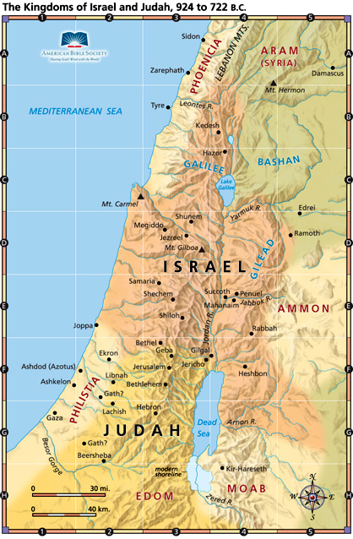
The next period of Israel’s history was one of civil war, known to Bible scholars as the period of the Divided Kingdom. When Solomon died, his son Rehoboam assumed the throne and rather than lower taxes, Rehoboam decided to raise the already steep rate. Rather than pay the higher tax, the ten northern tribes of Israel revolted under a man named Jeroboam (I), to form their own nation. The ten northern tribes were still known as “Israel,” and the two southern tribes became known as “Judah.” It is impossible in one study to give all the details of each ruler’s actions so we will merely list their names, if they served the Lord, how they died if not from natural causes, and how long they reigned. We will also mention the prophets alive in their time. Their stories are found in the books of 1 Kings, 2 Kings, and 2 Chronicles. All kings of the Northern tribes did not serve the Lord.

The Nineteen Kings of Israel (the Northern tribes): (y=years, m=months, d=days)
Jeroboam I, (22y); Nadab, slain (2y); Baasha (24y); Elah, slain (2y); Zimri, suicide (7d); Omri (12y); Ahab, slain (22y); Ahaziah, accident (2y); Jehoram, slain (12y); Jehu (28y); Jehoahaz (17y); Jehoash (16y); Jeroboam II (41y); Zacariah, slain (6m); Shallum, slain (1m); Menahem (10y); Pekahiah, slain (2y); Pekah, slain (20y); Hoshea, died in prison (9y).

The Nineteen Kings (and one queen) of Judah (the Southern tribes):
Rehoboam, good then evil (17y); Abijah, evil (3y); Asa, good (41y); Jehoshaphat, very good (25y); Jehoram, evil (8y); Ahaziah, evil, slain (1y); Athaliah, evil queen, slain (6y); Joash, good then evil, slain (40y); Amaziah, evil, slain (29); Uzziah, good then evil (52y); Jotham, evil (16y); Ahaz, very evil (16y); Hezekiah, very good (29y); Manasseh, very evil (55y); Amon, very evil, slain (2y); Josiah, very good, slain in battle, (31y); Jehoahaz, died in Egypt, (3m); Jehoiakim, evil died in Babylon (11y); Jehoiachin, evil, died in Babylon (3m); Zedekiah, evil, died in Babylon (11y).

After lasting about 250 years, the northern kingdom of Israel was taken into captivity in the ninth year of King Hoshea’s reign by the Assyrians (II Kings 17:5-6). The Assyrians brought in people from other captured lands to live in Samaria. These new groups mixed with the few Jews left to create a new, mixed-race people known as Samaritans. The majority of the northern tribes fade into Biblical obscurity at this point in scripture.
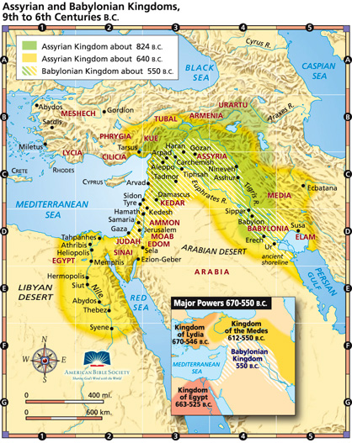
The southern kingdom of Judah lasted 134 years after the capture of Israel. In the time of Israel’s defeat to the Assyrians, Hezekiah was king of Judah, and through the help of the prophet Isaiah, Hezekiah was able to hold off the Assyrians although he began to pay them an annual tribute. Unlike his father, King Manasseh was very evil, and God allowed the Assyrians to conquer Jerusalem during his reign. During the reign of Josiah, Babylon attacked Assyria and King Josiah was killed in battle with the Egyptians who were trying to help Assyria. In King Jehoiakim’s reign, Babylon defeated Assyria and thus assumed political control of Judah. Because of Jehoiakim’s rebellion, Babylonian King Nebuchadnezzar laid siege on Jerusalem taking away a number of princes including the prophet Daniel. When King Jehoiachin also was disloyal, Nebuchadnezzar again came to Jerusalem, this time taking away 10,000 of the best workers of the city including the prophet Ezekiel. When King Zedekiah also rebelled, the Babylonians returned a third time, utterly destroyed Jerusalem, and took the best of the remaining Jews into captivity.

The small group of Jews who remained after the Babylonian conquest began to fight amongst themselves, and, fearing the wrath of Nebuchadnezzar, fled into Egypt taking the prophet Jeremiah with them. Prophets before the captivity included Elijah, Elisha, Joel, Jonah, Amos, Hosea, Isaiah, Micah, Zephaniah, Jeremiah, Nahum, and Habbakkuk. All wrote books of the Old Testament containing their story except Elijah and Elisha whose stories are found with the kings of their day. Prophets during the time of the exile (while the Jews were in captivity) were Daniel, Ezekiel, and Obadiah.

For 50 years after the fall of Jerusalem, the Jews were forced to live in Babylon. There were positive results of their captivity because they were forever cured of idolatry and Moses’ law became their focal point of living. The Jewish people also fully realized their blessed identity as a nation while in exile. When the great king Cyrus became King of Persia, he conquered the majority of the kingdoms around him including Babylon. Unlike the Babylonian kings, Cyrus decreed that all people were free to return to their homeland

Ezra 1:2-3 "Thus says Cyrus king of Persia, 'The LORD, the God of heaven, has given me all the kingdoms of the earth and He has appointed me to build Him a house in Jerusalem, which is in Judah. 3 'Whoever there is among you of all His people, may his God be with him! Let him go up to Jerusalem which is in Judah and rebuild the house of the LORD, the God of Israel; He is the God who is in Jerusalem.

Slowly, the Jews began to return to Jerusalem and the Promised Land. A group under Zerrubabel first returned and began to rebuild the temple. Later, a second group came under the priest Ezra and began to once again teaching Mosaic Law and worship. A third group soon came under Nehemiah and began to rebuild the walls of Jerusalem. The stories of their return, struggles, and triumphs are found in the books of Ezra and Nehemiah.

After king Cyrus died, a King Darius began to reign and it was under Darius’ rule that the story of Daniel and the lion’s den takes place. After King Darius’ death, a man named Ahasuerus became ruler of Persia, and it was in his reign that God caused circumstances to arise so that a Jewish girl named Esther became queen of all of Persia! This terrific story of perseverance and courage is found in the book of Esther. The Jews continued to live in peace in their rebuilt Jerusalem under the rule of the Persian kings until the end of the Old Testament, and prophets during this final time period of the Old Testament were Haggai, Zechariah, and Malachi. The Old Testament closes around 400 B.C. with these words:

Mal 4:4-6 "Remember the law of Moses My servant, even the statutes and ordinances which I commanded him in Horeb for all Israel. 5 "Behold, I am going to send you Elijah the prophet before the coming of the great and terrible day of the LORD. 6 "He will restore the hearts of the fathers to their children and the hearts of the children to their fathers, so that I will not come and smite the land with a curse."
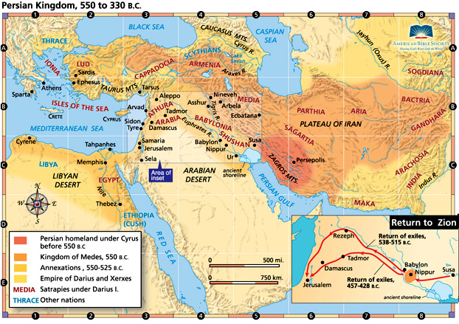
After these words, God ceased to talk directly to His people for four hundred years that are referred to by scholars as the Inter-Biblical Period because they took place between the Old and New Testaments. Because there were no prophets, no display of miracles from God, and no angelic visitations during these four centuries, the years between the testaments are often referred to as “the silent years.” Despite the lack of a visible witness, God was working throughout this period "behind the scenes" to get everything ready and set for the Messiah to come to Israel.

There were several Jewish books written during this time of divine silence including 1 Esdras, 2 Esdras, Tobit, Judith, additions to Esther, The Wisdom of Solomon, Ecclesiasticus, Baruch, The Song of the Three Holy Children, The History of Susanna, Bel and the Dragon, The Prayer of Manasseh, 1 Maccabees, and 2 Maccabees. Collectively the books written in this time are referred to as the Apocryphal Books or "hidden books." While valuable as historical references, we do not include the Apocrypha in the Holy Scriptures because they were written during a time when God was verbally silent therefore they could not have been divinely inspired. Further validating this point is the fact that in Jesus' ministry, He often quoted from many Old Testament books but never once quoted from any of the Apocrypha. Moreover, these specific books are never mentioned by any other New Testament author, despite the hundreds of quotes from Old Testament books found in the New Testament.

The Old Testament closes with the Jews still under Persian rule. In 334 B.C., Alexander the Great became commander of the Greek army and set out to conquer the world. This world included Persia and Jerusalem, and the Jews fell under Alexander’s rule. Jewish legend states that meeting the Greek army outside Jerusalem were two priests who impressed Alexander the Great so much that he did not destroy the city. Whatever the reason, Alexander did treat the Jews with favor, even granting them the privilege of citizenship in his new kingdom. Alexander the Great's coming was important for several reasons: that are not obvious to the casual Bible reader: first, the language of Greek became the universal language of the world thus setting the stage for the ministry of the Early Church. Secondly, the Jewish scholars translated the Old Testament scriptures into the Greek language, and this text became the scriptures from which Jesus and His disciples often quoted and preached.

Alexander the Great died in 323 B.C. and his kingdom was divided among his four generals-- Ptolemy, Lysimachus, Cassander, and Seleucus. Ptolemy became the ruler over the Jewish region a region, which was also coveted by Seleucus, who was given the less desirable Egyptian lands to the south. Ptolemy was hard on the Jews at first, but then began to appreciate them. Throughout his reign, he was constantly at war with Seleucus who was attempting to sieze them for himself. In fact, the fighting over the land of Canaan was so fierce, that in the twenty-five years after Alexander the Great’s death, the capitol city of Jerusalem changed hands seven times! In 198 B.C. the Seleucids finally assumed permanent control of Jerusalem and the Jewish people came under another kingdom’s rule.

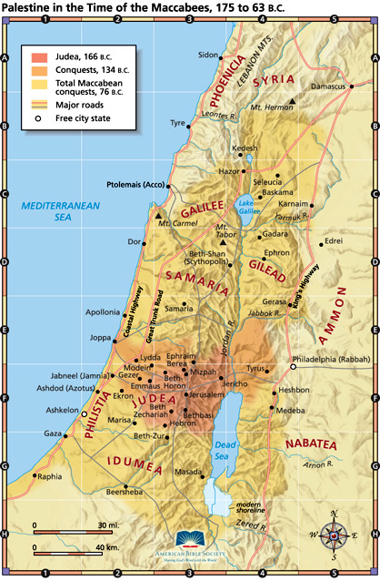
At the time of the Jerusalem conquest, a man named Antiochus III ruled the Seleucids. When he died in 187 B.C., Seleucus IV became king and ruled until 176 B.C. The easy years under these rulers came to an abrupt end when the infamous Antiochus Epiphanes came to power whose cruelty and harshness made him extremely disliked by almost everyone, including the Jews. In 169 B.C., when the Jews received a false report that Antiochus Epiphanes had died, they immediately began to celebrate in the street. Unfortunately, not only was Antiochus alive but he was visiting the city and witnessing celebrations of his "death" caused his hatred of the Jews to become fanatical rage. The change was so profound that many historians believe he went partially insane at this time.

1 Maccabees 1:21-23 He arrogantly entered the sanctuary and took the golden altar, the lampstand for the light, and all its utensils. 22 He took also the table for the bread of the Presence, the cups for drink offerings, the bowls, the golden censers, the curtain, the crowns, and the gold decoration on the front of the temple; he stripped it all off. 23 He took the silver and the gold, and the costly vessels; he took also the hidden treasures that he found. NRSV Apocrypha

Fueled by intense hatred, Antiochus immediately began to try to stamp out the Jewish lifestyle and modes of worship even going so far as offering pigs – unclean animals – upon the altar in the temple and promising to kill anyone who worshipped Jehovah God of Israel. In his maniacal rage, Antiochus also severely underestimated the Jewish loyalty to their God, which in the end proved to bring an end to his rule in Israel.

One of the common practices of persecution of the Jews by Antiochus was to take some soldiers into a village, make all of the Jewish people line up and pass one by one in front of an idol and, if they did not worship the image, kill them. In 167 B.C. an old Israeli father by the name of Mattathias was in such a line when he became angered when the young man in front of him bowed to the idol and willingly broke the commandments of Moses in order to save his life. The old man grabbed a sword from the sheath of a nearby soldier, first killed the young man, and then killed the surrounding soldiers. He then started a Jewish revolt and placed his sons at the forefront of the fight. The newly formed rebels were led by his eldest son, Judas, and were to be known as the Maccabeans. Through a series of brave and strategic battles among the hills, the Maccabeans won their independence from the Seleucid and Syrian armies. On December 25, 165 B.C., the Maccabeans rededicated the Jerusalem temple to God. The modern Jewish celebration Hanukah or "the Feast of Lights" is in commemoration of this event.

After Judas’ death in 161 B.C., various rulers were in control of Israel throughout its independence and during this time two political parties became very prominent in Israeli affairs. The Pharisees were a conservative group of the similar beliefs of their late leader Judas. The Pharisees were the majority party and held fast to the Mosaic Law and traditions. Their counterparts were the Sadducees who were more liberal in their thinking and, while Jewish, were more open in adopting the philosophy of the Greeks. These two party's constant clashes for control of the Jewish nation, ultimately led to another civil war in 69 B.C. which continued until 63 B.C., when Pompey the Roman general came and conquered the land placing the Jews firmly under the Roman rule. The Roman conquest was important because they built excellent roads between major towns and instituted ship routes for trade and it would be upon these roads and ship routes that would be used by the Early Apostolic Church to preach Jesus Christ to the entire known world! Silently, God was setting the scene for the magnificent revealing of the coming of the promised Messiah!

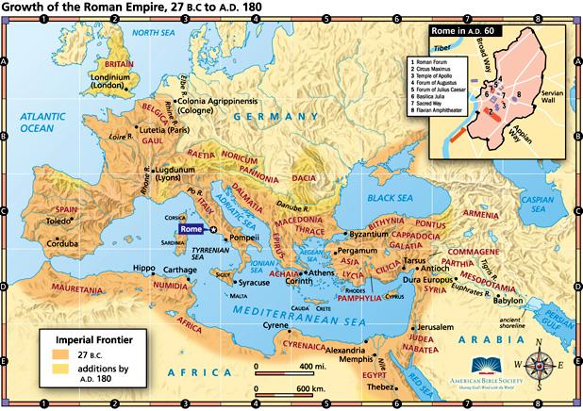
Pompey was later killed by Julius Caesar who was eventually also killed, leaving the Roman kingdom in a political struggle. Caesar Augustus eventually became ruler of the kingdom with Herod the Great being placed as the ruler of the Jewish area called Judea. It would be into this setting that Jesus Christ was born in 4 B.C.

For someone who began his ministry with a so-called "speech impediment," Moses certainly spoke a long time! The book of Deuteronomy is 34 chapters long, 33 of which is Moses speaking.
A quick glance at the order of the Old Testament books will reveal that Obadiah is out of place chronologically. The prophets' books were grouped according to size and not according to date.
It is Exra who is largely responsible for compiling the Old Testament books in the form and order that we have today.
Ahasuerus is his Hebrew name, in history, he is more commonly called "Xerxes."
We still have copies of this translation today and it is called the "Septuagint."
"Maccabees" means "hammerers" in Hebrew, as in they "hammered the enemy rule into pieces."
Early Greek philosophy is commonly known as "Hellenism."
Endnotes ? Because he is mentioned in Joshua 14:1 as having helped to divide up the Promised Land, it is possible that Eleazar, the High Priest in Joshua's reign, was the one other person of the generation of doubt that entered into the Land of Canaan. That he was under the age of twenty at the time of doubt seems unlikely because Eleazar was in charge of those who ministered in the Tabernacle in Numbers 3:32. The age for priest to begin to serve was 30 (Numbers 4:3) so it seems that although rarely mentioned or preached, there was one other male who believed that God could give them the Promised Land and that stood with Joshua and Caleb and refused to doubt, the priest Eleazar!
The last three stories of the book of Judges are truly horrific, with scenes that remind me of our modern, daily newspaper. Most scholars believe that these horrible stories were recorded as an example of just how bad it was living in a land where "there was no king, and every man did that which was right in his own eyes." Though we have governmental authority, truly we live today in a land where Jesus Christ is not King and Lord of all. We should not be surprised at the horrible things that take place everyday that we read about in the news, because such is the fate of a society without Jesus as their king and where all do as they deem right.
The differences in the anointings of Saul and David are noteworthy considering their respective ends. 1 Samuel 10:1 says that Samuel poured the oil upon Saul from a "flask" indicating a man-made object. Yet when David was anointed king, the oil flowed from a container made from a bull's horn (1 Samuel 16:13). This typifies the callings of the respective kings, as Saul was only chosen because of the desire of the people to have a king and therefore was anointed with a man-made anointing, but David was chosen because he was God's perfect will for that time in Israel, and thus received a God-made anointing. How each king turned out is a powerful lesson to making sure that we step out and assume authority only when it is God's doing!
In his farewell speech in Deuteronomy, Moses spoke to the children of Israel about the time that would come when they would place a king over them. In his speech, Moses gave specific warnings to the man who would one day be king: Deut 17:14-20 "When you enter the land which the LORD your God gives you, and you possess it and live in it, and you say, ' I will set a king over me like all the nations who are around me,' 15 you shall surely set a king over you whom the LORD your God chooses, one from among your countrymen you shall set as king over yourselves; you may not put a foreigner over yourselves who is not your countryman. 16 " Moreover, he shall not multiply horses for himself, nor shall he cause the people to return to Egypt to multiply horses, since the LORD has said to you, 'You shall never again return that way.' 17 " He shall not multiply wives for himself, or else his heart will turn away; nor shall he greatly increase silver and gold for himself. 18 "Now it shall come about when he sits on the throne of his kingdom, he shall write for himself a copy of this law on a scroll in the presence of the Levitical priests. 19 "It shall be with him and he shall read it all the days of his life, that he may learn to fear the LORD his God, by carefully observing all the words of this law and these statutes, 20 that his heart may not be lifted up above his countrymen and that he may not turn aside from the commandment, to the right or the left, so that he and his sons may continue long in his kingdom in the midst of Israel. The very things that the law forbade, accumulating horses and marrying many wives, were the two things that Solomon did (1 Kings 10:28-11:3). If the words of Moses were obeyed, Solomon did these things despite having these commandments read to him every year! How important it is to heed the commandments of the written Word!
King Josiah was noteworthy for several reasons; one being that he was only eight years of age when he began his reign (2 Kings 22:1)! Even more remarkable is that despite having the influence of a very evil father and grandfather before him, Josiah "did that which was right in the sight of the Lord." The key to his living right is found in the following verse: 2 Kings 22:2 He did right in the sight of the LORD and walked in all the way of his father David, nor did he turn aside to the right or to the left. NASU Josiah "walked in all the way of his father David," and yet David was not his literal father but an ancient ancestor. Not having a role model in his immediate family, Josiah reached into history and found someone who pleased God and decided to emulate them! What a powerful lesson! If your immediate family has not been the greatest example in obeying God's Word, then go back to the Bible and find somebody like a King David or an Apostle Paul and decide for yourself: "I will walk before God as they walked!"

